Introduction to ITWS
Quiz 1: October 4, 2012

- Network protocols: (20 points, 10 minutes)
I am researching a subject for class. I open up my Browser and I go to my favorite search provider. I type in www.google.com and hit the enter key. A moment or two after I hit Enter, I see Google’s main search page in my browser.

  - How did my computer know where to “go”? (4 points).

  - How did my browser receive the search page from Google? (4 points).

  - After hitting the Enter key, what did my browser do in order to be able to display the main search page? (8 points).

  - What would I have seen if my connection to the Internet had not been working? (4 points).

- Communications and Networks: (20 points, 15 minutes)
  - Discuss one point made by our guest speaker, Nigel Westlake, that connects to key concepts of “Communications and Networks” as covered in this Course. Answer in complete sentences. (5 points)

  - We carried out a “Wide Area Networking In-Class Exercise”. List which world City and Country that you represented during this Networking Exercise. Discuss two important concepts that you learned from this Exercise about “Communications and Networking”. Answer in complete sentences. (5 points)

  - Based on the “Apple, Inc. in 2010” Case and considering “technologies”, “applications”, “competition”, “communications and networking principles”, and “Metcalfe’s Law”, will the iPhone or the iPad add more value to Apple Inc. over the next five years? Why? Answer in complete sentences. (10 points)

- Enterprise Applications and the Appirio Case: (20 points, 15 minutes)
  - How do Enterprise Applications “integrate” the functions and processes of a company? Discuss two different dimensions of “integration”. Answer in complete sentences. (6 points)

  - Discuss two “Advantages” and two “Disadvantages” of “Cloud Computing”. Answer in complete sentences. (8 points).

  - Discuss two differences between “Enterprise Applications” and “Social Networking”. (6 points)

- HTML, CSS, XML: (40 points, 30 minutes)

Create a single XHTML page that looks like the screenshot below. Guidelines:
- Use quiz1.html (in the LMS) as your starting template
- Use quiz1.txt (in the LMS) as a source for the text, hyperlinks, logo, and color values
- Use quiz1.jpg (in the LMS) as a reference (if the screenshot is hard to view)
- The width of the box is 620px.
- The topmost title box (“Quiz 1 – HTML”) should be an h1.
- Do your best to duplicate colors, borders, margin, padding, alignment, and font styles.
- Don't forget to set the page title.
- The page must validate.
- Use your labs, the course materials, and the web for reference.
- (Points: validity=10, indentation=4, completeness=10, quality=10 )
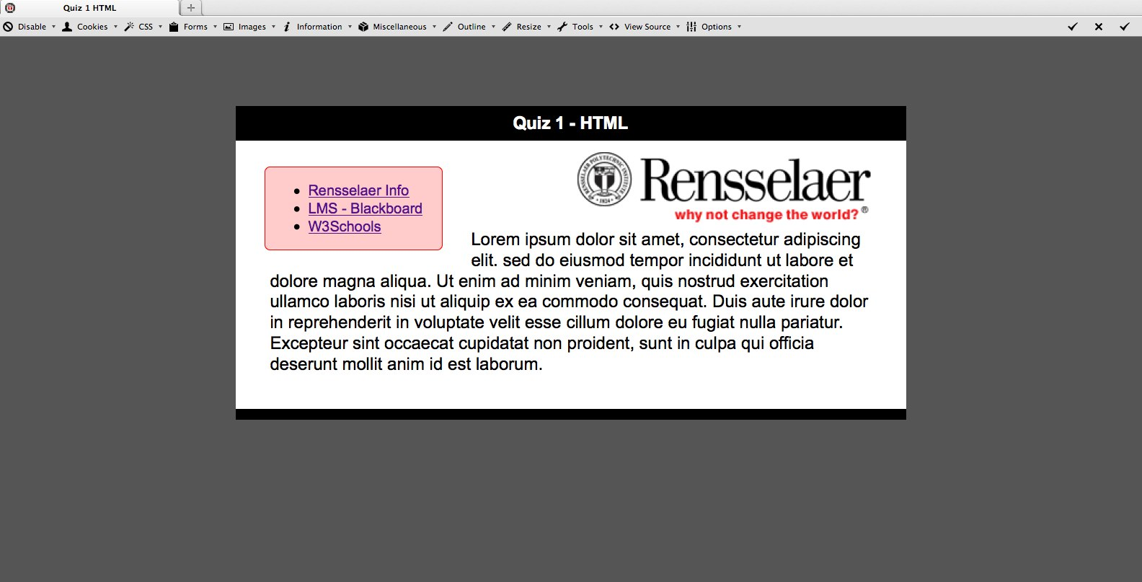
Completion:
When you are finished, post your completed quiz1.html file along with this finished word document to the assignment dropbox for this quiz.

